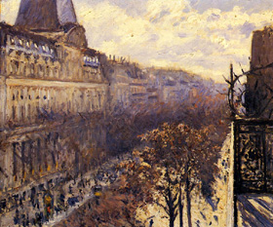

Class #10

Drawing in Perspective

Create a landscape drawing of the Highline horizontal format, (10”/20”, 12”/18”, 8” 18, etc.).

Points to think about:

The use of one point perspective is most important in rendering the illusion of space within a landscape. Find a spot where you’re comfortable and do thumbnail compositions of your idea. Come up with at least 3 interesting views you can execute within the allotted time.

Once your idea is composed – which should note the vanishing point, dominant vertical tones (people, poles, buildings), prominent areas of grey (ground, sky) and balance in composition and tonal range – prepare your larger sheet of paper to match the chosen thumb nail and begin your larger composition.

In PENCIL (very sharp, please) and a RULER, begin to regulate the major perspective lines to the VP (vanishing point) you have determined. Use a HB or lighter pencil to find the line. SEE THESE LINES AS A GUIDE, OR STRUCTURE, like BONES – you cannot see them but they support the whole. Don’t draw very heavy – draw light enough to make it hard to see these first lines, then build the tones up in hatching, smudging and other methods we have learned.

Switch from vertical objects to horizontal, all the while rendering tonal areas to support the whole drawing. Once you have secured enough (convincingly) space with tone and line, you should begin to flourish and find points of interest that might be understated, and not so apparent. DO not play out or overuse the same marks – create differing marks in regard to what it is you are seeing. As the people pass, let them go – making mental notes of how dark hair is compared to the ground or wall, how many shirts have patterns as apposed to none, or how many women have skirts. All these things will help later when you place people in the picture. Wait until you have rendered the scene before committing to put people in -- you can place them anywhere once your scene is established.

Key people into your thumbnail reference, not your final drawing in the beginning. Keep the points of interest vague until the finish.

When people stop, that is the time to render them in your sketchbook, not on the final drawing. Create reference examples to pull from, this way, when it is time to have more detail in figure within the landscape, you have the studying at the ready.

Note that the heads are more or less on the same horizon line as they recede, and they get fainter as they move back. Legs start to move upward toward the center as they reced. Edges also become less visible, appearing much more blurry as they go back in space. Figures in the foreground are always darker and more intense.

Homework:
Draw someone you admire – family or celebrity (minor or major). Juxtapose this with something that supports their personality or character trait(s). Bring in all work including photo references used. 18”/24” or within the confines, bordered with TAPE and presented neatly to the class next week. Pencil or ink on paper. You may use toned paper.

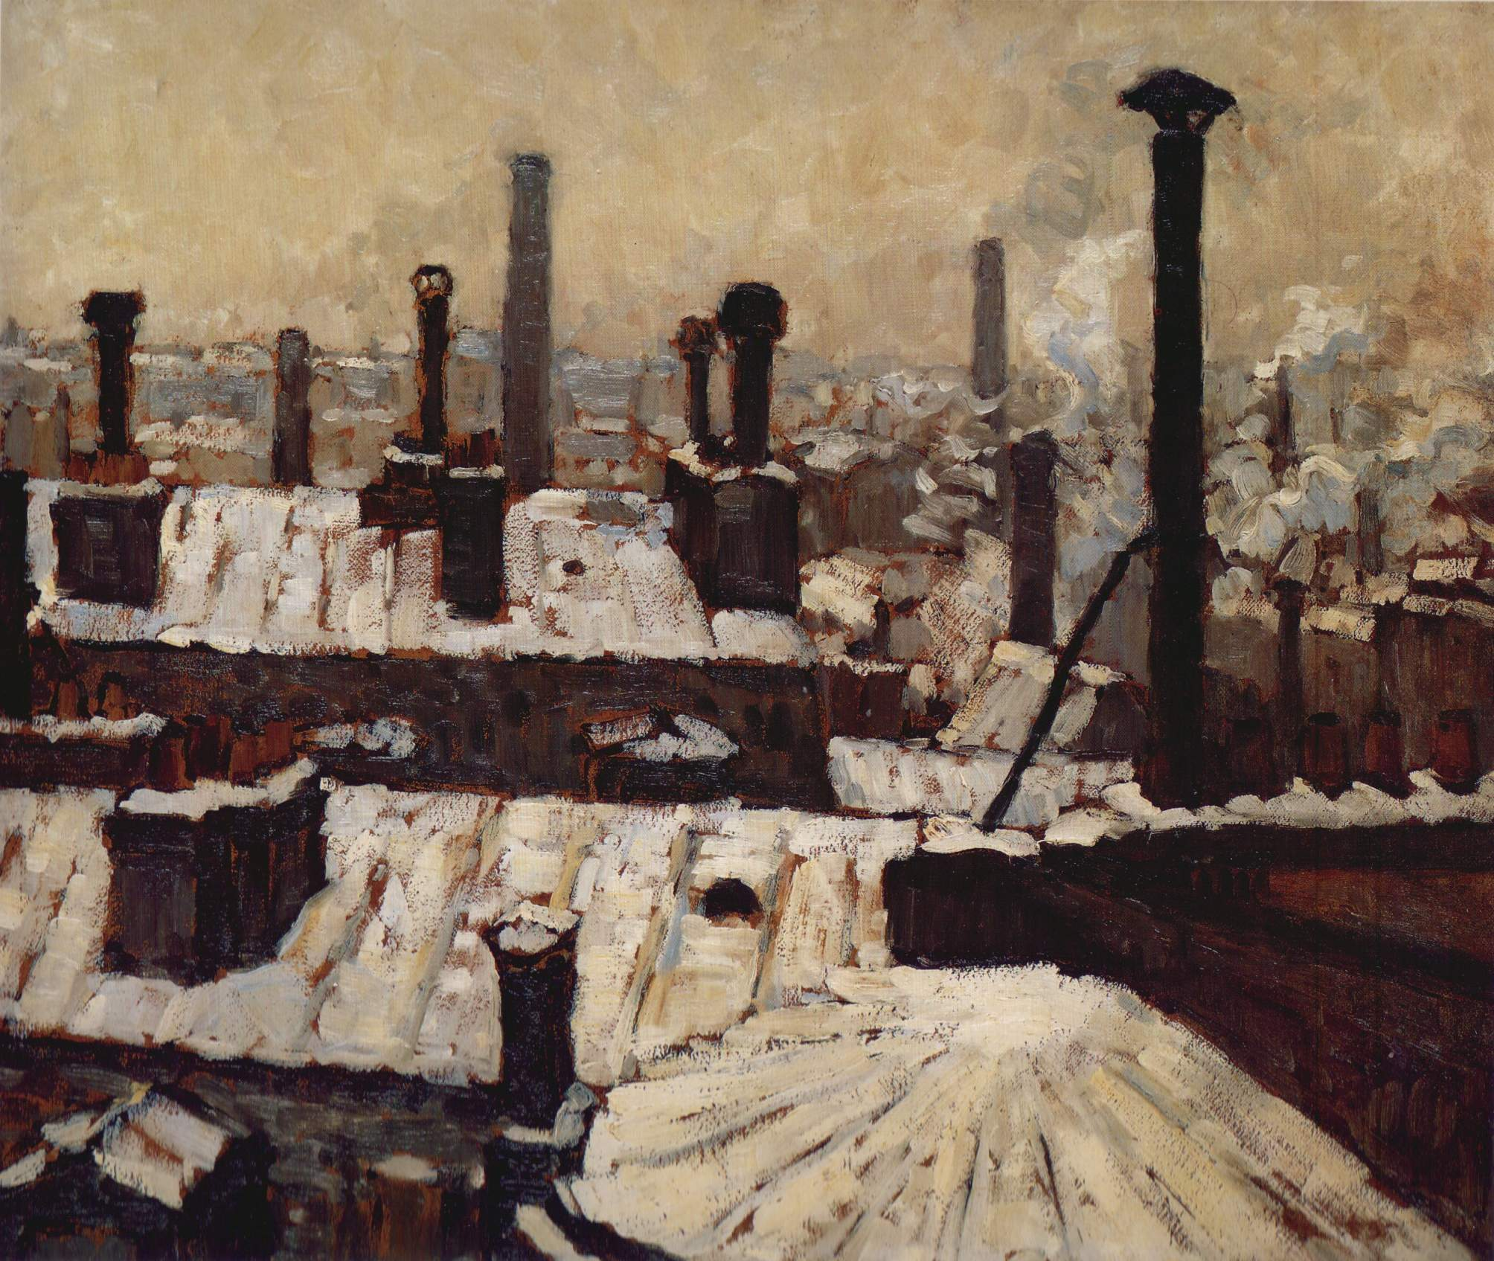

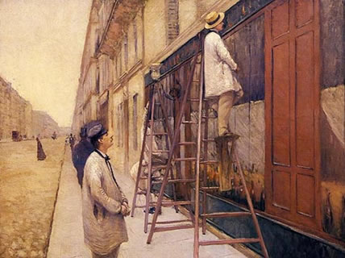

Gustave Caillebotte

